***Vodka Absolut Elyx***

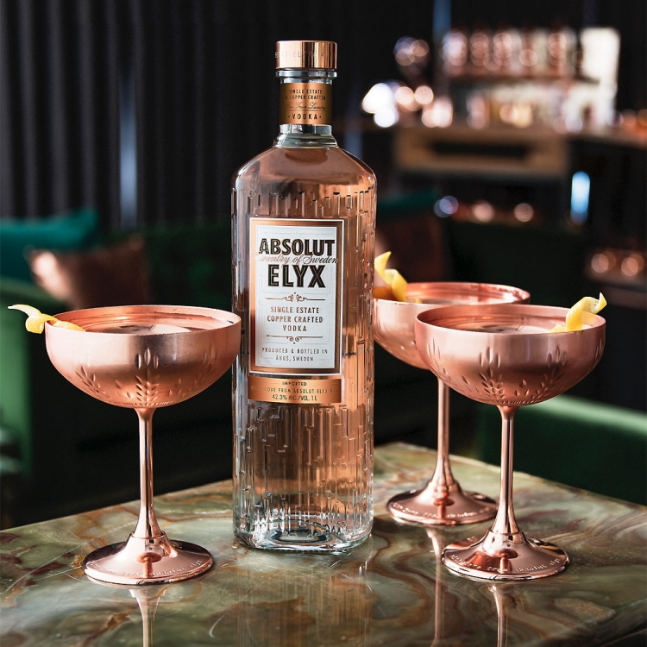

*"Absolut Elyx Vodka, Pernod Ricard, travel retail, announces the launch of Absolut Elyx, the new ultra-premium vodka.  
  
Crafted in small quantities from specially selected winter wheat granaries with purified source water, this vodka has been researched and developed for more than 10 years, the company says.  
  
Returning to the five-century legacy of the tradition of making vodka on the Skane farms, located in southern Sweden, Absolut restores the stillness that has been distilled since 1929 at the Ahus distillery. This factory uses the traditional type of barrel (copper) for unique taste, crystallization quality, excellent texture"*